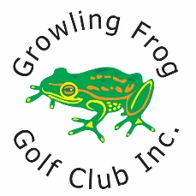

**PRO SHOP USE ONLY**

Amount Received ……………………………………………………………………………………………………………………………………..

Date Received ……………………………………………………………………………………………………………………………………..

Processed By ……………………………………………………………………………………………………………………………………..

**SECRETARY USE ONLY**

Payment Received ……………………………………………………………………………………………………………………………………

Receipt Reference ……………………………………………………………………………………………………………………………………

Golf Link Updated ……………………………………………………………………………………………………………………………………

LAST NAME: ……………………………………………..………….…… FIRST NAME: …………………………………………………….………..

ADDRESS: …………………………………………………..………………………………………….………………………………………………….………..

SUBURB: ………………………………………………………..…… POST CODE: ……………………..……………………………….………..

CONTACT NUMBER: …………………………………………… GOLFLINK: ………….……………….…………………………….………..

EMAIL: ………………………………………………………..…………………………………….………..……………….…………………………….………..

Subscriptions for membership renewal are due by **31st December 2023**, effective **1st January 2024.**

To ensure your Golf Link account remains current and to be eligible to keep playing in Club Competitions, please make your renewal payment by the due date noted.

Adult Fee: **$170**

Junior (under 18) Fee: **$40**

Cash/Cheque/Credit Card Payable via the Pro Shop

Electronic Funds Transfer (EFT) Account Name: Growling Frog Golf Club Inc

Account No: 172710410

BSB: 633-000

**IMPORTANT** – When paying by EFT, remember to include your last name and initial as a reference to ensure the club can accurately track payment.

Please complete the following fields to ensure our records are up-to-date:

**Growling Frog Golf Club Inc.**

Membership Renewal Form